PSEUDO CODE

The fallowing pseudo code was created for the game. It shows the plan of writing the proper functions.

Show SVG graphic()

Button “play”.addEventListener(click, () {

Display the list of horses - add animation

allHorses.forEach(
element.AddEventListener(click, (){
create variable that holds the information about chosen horse
horseRace( )
}
}

function horseRace (){

for (all the horses){
let durationOfAnimation = math.random()
set the animation so that they move along the line
chosenHorseLine.style.opacity = 1
let newArrayHorses = [ push here horses that finished the race ]
let newArrayTimes = [push here duration of animation calculated for each horse] ← sort the array in the right order
}
}

function showScores () {

display the table with the results – based on created arrays
rowWithChosenHorse.style.opacity = 1
Show the points that user won together with the graphic of a horse that they have chosen.
}

GreenSock – javascript library

To be more efficient we decided to use GreenSock library for the game animations. This modern, easy to understand and powerful framework turned out to be a great tool that allowed us not only to achieve desired effects but also save time that we would spend on hand coding all the animations by using css keyframes. For the purpose of gaining some more experience we used tweenMax, along with tweenLite and Timeline tools.

The example of the code :
Using the following code we animate the scene in which we present the list of horses that will take part in the race. Each horse has it's own “box” that contains the image, name and short description. The boxes fall down from above (the start point is y: “-=519”) and stops in the given position. The duration of the animation is set to 1 second, but each box will fall with some delay which is calculated and depends on the index value (delay: i / 2). For some nice effect we used elastic easing which comes form greenSock library. Each fall of the box is preceded by the whoosh spund.

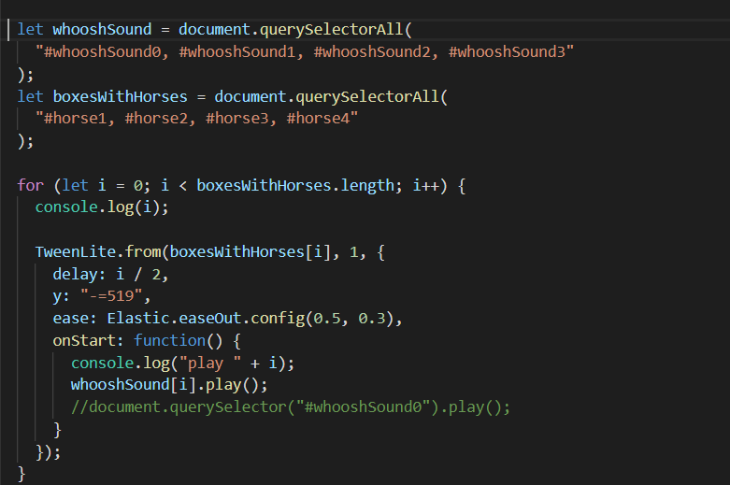

let whooshSound = document.querySelectorAll(
"#whooshSound0, #whooshSound1, #whooshSound2, #whooshSound3"
);
let boxesWithHorses = document.querySelectorAll(
"#horse1, #horse2, #horse3, #horse4"
);

for (let i = 0; i < boxesWithHorses.length; i++) {
console.log(i);

TweenLite.from(boxesWithHorses[i], 1, {
delay: i / 2,
y: "-=519",
ease: Elastic.easeOut.config(0.5, 0.3),
onStart: function() {
console.log("play " + i);
whooshSound[i].play();
//document.querySelector("#whooshSound0").play();
}
});
}

Before creating the high fidelity prototype we drew our ideas in a storyboard where we also described interactions and sounds of each scene in details.

Flowchart game

The following diagram shows the flowchart of the game. At the beginning on the game the user decides which horse they would like to bet on. This decision has its consequence through the whole game. The chosen horse is always highlighted so that the user should not be confused. When the race is finished and the scores are presented the user can decide if they want to go further to see their points or play again.

